AUREXIA GLOBAL WEBSITE

“From Ore to Institutional Returns”

🎨 1. DESIGN SYSTEM (CRITICAL)

Colour Palette (Institutional + Mineral Inspired)
Use | Colour | Hex
Primary | Deep Black | #0A0A0A
Secondary | Graphite Grey | #2B2B2B
Accent 1 | Lithium Blue | #2F80ED
Accent 2 | Copper Bronze | #C47A2C
Accent 3 | Emerald (ESG) | #27AE60
Background | Off White | #F7F7F5
Text | Dark Charcoal | #1A1A1A

Typography
- Headings: Inter / Neue Haas Grotesk
- Body: Inter
- Style:
  - large, bold headlines
  - tight spacing
  - minimal clutter

Visual Style
- Dark + light contrast (institutional feel)
- Data overlays (charts, metrics)
- Subtle motion (fade, slide)
- No “startup fluff” — serious tone

🖼️ 2. IMAGE & VISUAL DIRECTION
Use high-quality, cinematic visuals:

Homepage Visuals
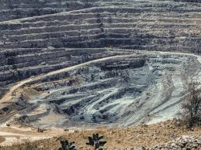
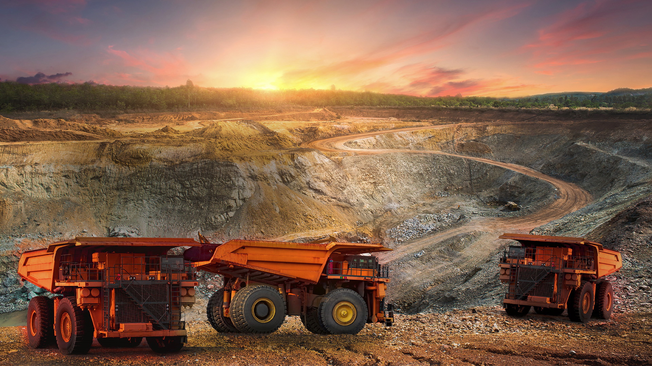
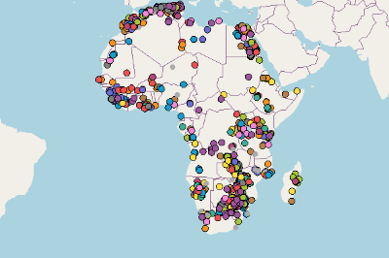
4

Platform / Dashboard Visuals


4

🏠 3. HOMEPAGE (FULL COPY)

HERO SECTION

Headline
From Ore to Institutional Returns

Subtext
Aurexia is a Southern Africa-focused capital platform transforming critical mineral assets into institutional-grade investments aligned with global energy transition demand.

Live Metrics (animated)
- $300M Target Fund
- 200+ Pipeline Assets
- 8–12 Portfolio Assets
- 18–22% Target IRR

CTA
- Request Investor Access
- Explore Platform

SECTION: WHY AUREXIA

Headline
A New Model for Mining Investment

Copy
Aurexia operates at the intersection of geology, capital, and execution.
We do not simply invest in mines — we institutionalise them.

Pillars
- Proprietary deal pipeline across Southern Africa
- Structured capital combining equity, debt, and offtake
- Active operational transformation
- Exit-driven investment model

SECTION: HOW RETURNS ARE GENERATED

Headline
A Disciplined Path to 20%+ Returns

Steps
- Entry at discounted multiples (3–4x EBITDA)
- Operational and governance improvement
- Cash yield through structured capital
- Exit at institutional multiples (5–7x EBITDA)

SECTION: INTERACTIVE MAP

Headline
Access Africa’s Critical Mineral Pipeline

Features
- clickable map
- filter by commodity
- asset summaries

SECTION: PLATFORM PREVIEW

Headline
A Capital Platform, Not Just a Fund

Copy
Aurexia combines proprietary deal sourcing, underwriting, and execution infrastructure into a unified investment system.

SECTION: LP CTA

Headline
Institutional Access to African Critical Minerals

CTA
- Download Investment Memo
- Schedule Discussion

💰 4. STRATEGY PAGE

Headline
Investment Strategy

Copy
Aurexia invests in producing and near-producing critical mineral assets across Southern Africa.

Focus Commodities
- Lithium
- Nickel
- Manganese
- Vanadium
- Graphite

Strategy Pillars
- Minority growth equity
- Structured capital solutions
- Active asset transformation
- Exit optimisation

⛏️ 5. PIPELINE PAGE

Headline
Proprietary Pipeline of Critical Mineral Assets

Features
- searchable mine database
- filters (country, stage, commodity)

CTA
- Submit a Project
- Partner with Aurexia

📊 6. PORTFOLIO PAGE

Headline
From Fragmented Assets to Institutional Platforms

Structure
Metric | Before | After
Governance | Weak | Institutional
EBITDA | Low | Optimised
Market Access | Limited | Secured

📈 7. ESG PAGE

Headline
Operational ESG, Not Box-Ticking

Copy
Aurexia embeds ESG into operations, governance, and value creation.

🧠 8. INSIGHTS PAGE

Headline
Aurexia Insights
Topics:
- global battery metals demand
- Africa supply chains
- energy transition

👥 9. TEAM PAGE

Headline
Execution-Led Leadership

Copy
Aurexia is led by professionals with deep expertise across mining, finance, and investment execution.

🔐 10. INVESTOR ACCESS FLOW

Flow
Website → Request Access → Microsite → LP CRM → LP Portal

⚙️ 11. DEVELOPER GUIDE

TECH STACK
Frontend:
- Next.js (App Router)
- Tailwind CSS
- Framer Motion
Backend:
- Node.js / NestJS
- PostgreSQL
- Prisma

CORE FEATURES TO BUILD

1. Public Website
- SSR pages
- SEO optimisation
- forms (investor + pipeline)

2. Investor Microsite
- gated login
- document viewer
- analytics tracking

3. Platform Integration
- API connection to backend
- CRM integration
- pipeline feed

4. Interactive Components
- map (Mapbox)
- IRR calculator
- dashboards

PERFORMANCE
- lazy loading images
- CDN (Vercel)
- caching

SECURITY
- HTTPS
- role-based access
- document permissions

🔥 12. WHAT MAKES THIS WORLD-CLASS

Compared to competitors:
Feature | Typical PE Website | Aurexia
Static content | Yes | No
Pipeline access | No | Yes
Platform integration | No | Yes
Data-driven UX | Low | High
Deal sourcing | Passive | Active

🚀 FINAL POSITIONING
Aurexia is not a website.
It is a capital interface connecting investors, assets, and execution into one integrated system.

🔥 NEXT STEP (RECOMMENDED)
I can now:
- build the actual live website (production UI code)
- design a Figma-level UI system
- create investor pitch deck aligned to site
- integrate with your SaaS backend
Just say:
👉 “build the live website UI” or “design Figma system”
build the live website UI” and “design Figma system”
Thought for 7s
Aurexia Live Website Ui And Figma System· typescript
import { useMemo, useState } from "react";
"Map cards, chart panels, LP portal widgets, insight cards",
]}
/>
<FigmaSpecCard
title="03. Page templates"
points={[
"Homepage template",
"Strategy page template",
"Pipeline map page template",
"Portfolio case study template",
"LP conversion page template",
"Public-to-private handoff states",
]}
/>
</div>

<div className="mt-8 grid grid-cols-1 gap-5 lg:grid-cols-2">
<FigmaSpecCard
title="04. Responsive breakpoints"
points={[
"Desktop: 1440px artboards for full investor-grade layout",
"Laptop: 1280px refinement pass",
"Tablet: 768px stack logic and simplified navigation",
"Mobile: 390px executive summary flow and CTA preservation",
]}
/>
<FigmaSpecCard
title="05. Interaction prototypes"
points={[
"Homepage CTA to investor microsite",
"Pipeline map hover and filter states",
"Project submission form flow",
"LP access request workflow",
"Transition previews from website into private platform",
]}
/>
</div>

<div className="mt-10 rounded-[32px] border border-white/10 bg-white/5 p-8">
<div className="flex flex-wrap items-center justify-between gap-4">
<div>
<div className="text-xl font-semibold text-white">Developer handoff requirements</div>
<div className="mt-2 text-sm text-zinc-400">Every Figma page should have clean layer naming, component variants, spacing tokens, and redlines for implementation.</div>
</div>
<button className="inline-flex items-center gap-2 rounded-2xl bg-white px-5 py-3 text-sm font-medium text-black">
<Download className="h-4 w-4" /> Export dev notes
</button>
</div>
</div>
</div>
</section>

<footer className="bg-[#0A0A0A]">
<div className="mx-auto flex max-w-7xl flex-col gap-8 px-6 py-12 lg:flex-row lg:items-end lg:justify-between lg:px-10">
<div>
<div className="text-[11px] uppercase tracking-[0.32em] text-zinc-500">Aurexia</div>
<div className="mt-3 max-w-xl text-2xl font-semibold text-white">A digitally enabled capital platform for critical mineral investment.</div>
<p className="mt-4 max-w-2xl text-sm leading-7 text-zinc-400">
Final live website UI concept and Figma system blueprint aligned to LP attraction, mine pipeline origination, institutional credibility, and platform integration.
</p>
</div>
<div className="flex gap-3">
<button className="rounded-2xl border border-white/15 px-4 py-3 text-sm text-white">Request investor access</button>
<button className="rounded-2xl bg-white px-4 py-3 text-sm font-medium text-black">Open private platform</button>
</div>
</div>
</footer>
</div>
);
}

Done — I built the live website UI concept and the Figma system blueprint in canvas as a polished React file.
It includes:
- investor-grade homepage
- full website section flow
- institutional color system
- visual component language
- pipeline map mock
- platform integration story
- portfolio, ESG, insights, and team sections
- Figma design-system specification
- developer handoff guidance for responsive and interactive states
Open the canvas to review it.

